COVID-19 Exposure & Control Plan

May 21st, 2020
Master Copy
(all staff)

COVID-19 Exposure & Control Plan
May 21st, 2020
A big thank you to OneSky for allowing us to use their COVID Exposure and control plan. We have adapted it to our use and needs.

As the COVID-19 outbreak unfolds, ACCESS remains committed to providing a safe and healthy workplace for all of our participants, staff and volunteers. We are implementing a range of measures to minimize exposure to COVID-19 while working tirelessly to ease the spread throughout our facilities and resources.
The COVID-19 Exposure and Control Plan (C19 Plan) will be shared with all staff and updated as needed. All staff and volunteers must read the C19 Plan, and follow the procedures outlined in the C19 Plan to prevent or reduce exposure to COVID 19.

•
CLBC
•
Public Health Agency
of Canada
•
BC Government
•
Interior Health
•
World Health
Organization
•
Universal Safe Work
Procedures/
Prevention
•
Quarantine
Measures
•
Point of Care Risk
Assessment
•
Legal Assistance
Services
•
Community Outreach
outreach
Services
•
Resource & Referral
•
PWD Services
•
Counselling
Services
•
Tax Service

•

•
All staff and volunteer
responsibilities
•
Staff/Volunteers
returning from travel
outside of Canada
•
Staff/Volunteers who
have had contact with
someone diagnosed
with or presumed to
have COVID
-
19
•
Staff/Volunteers who
have had close contact
with someone who is
displaying symptoms
1
. ACCESS Staff
Responsibilities
. Guielines for
2
staff coverage,
work location
and program
status
. Reliable
4
Information
Links
3
. COVID
-

19
Training Plan

1. ACCESS Staff/Volunteer Responsibilities

All ACCESS Staff/Volunteer Mandatory Measures
- Avoid areas where there are large crowds (50 or more people) and/or crowded areas, including public facilities, events and public transit
- Avoid shared spaces where possible
- Ensure social distance wherever possible, (2 meters from others) when outside of your personal home, and avoid any unnecessary contact including handshakes and hugs
- Cancel any activities that may risk exposure
- Take special precautions for those with compromised immune systems
- Stay home if you are feeling unwell, for any reason, and/or have symptoms of COVID-19 (fever, cough, muscle aches, difficulty breathing, runny nose, sore throat, or diarrhea). Follow Medical Health Office guidelines for seeking medical attention and contact your direct supervisor.
- If you are feeling unwell and/or do have symptoms of COVID-19, do not come to work. Contact your direct supervisor and access self-assessment tools via:
  - Online self-assessment tool at www.bc.thrive.ca
  - Calling 8-1-1
  - Downloaded app – BC COVID-19 support (available on Apple App Store or Google Play)
- Contact your direct supervisor if you suspect that a participant and/or family member/stakeholder/co-worker has symptoms of COVID-19
- Self-isolate at home on days when not required at your workplace
- Continue to self-monitor your health and the health of your children for symptoms such as fever, cough, muscle aches, difficulty breathing, runny nose, sore throat, or diarrhea
- Prepare in advance for your personal life in the event of exposure or diagnosis of COVID-19 (e.g. childcare, quarantine of yourself or family member)
- Follow the COVID-19 Training Plan that outlines:
o Proper handwashing, sneezing and coughing etiquette o Universal work procedures/prevention o Point of Care Risk Assessment o Personal Protective Equipment Protocol
ACCESS Staff/Volunteers with Symptoms
- If you think you have symptoms of COVID-19, even one, (fever, cough, muscle aches, difficulty breathing, runny nose, sore throat, or diarrhea), or even mild symptoms, you should stay home to avoid spreading illness to others. Call your direct supervisor to inform. Please see Appendix 1 for information on Self-Isolation
- If you develop even mild symptoms while at your workplace, call your direct supervisor. Wherever possible, wear a mask and separate yourself from your colleagues and go home, avoiding use of public transit if possible. If you are unable to leave the workplace (due to critical staff levels), isolate yourself as best as possible and call your direct supervisor
- If applicable, in conjunction with your direct supervisor, inform any clients/participants or family members that you may have been in contact with while symptomatic (e.g. caregivers of children in childcare resources; caregivers and staff members connected to staffed residential services, etc.)
- If you think you might have COVID-19 you can access self-assessment tools via:
  - Online self-assessment tool at www.bc.thrive.ca
  - Calling 8-1-1
  - Downloaded app – BC COVID-19 support (available on Apple App Store or Google Play)

ACCESS Staff/Volunteers Returning from Travel outside of Canada
- Employees/Volunteers who have returned from international travel must abide by the 14-day mandatory self-isolation as per the guidelines from the Provincial Medical Health Officer, Dr. Bonnie Henry (see Appendix 1)
- Employees/Volunteers in self-isolation should self-monitor (see Appendix 2) daily for signs and symptoms of COVID-19 such as fever, cough, muscle aches, difficulty breathing, runny nose, sore throat, or diarrhea
- If you develop symptoms, you can access self-assessment tools via:
  - Online self-assessment tool at www.bc.thrive.ca
  - Calling 8-1-1
  - Downloaded app – BC COVID-19 support (available on Apple App Store or Google Play)
- Employees/Volunteers who have self-isolated can return to normal activities after
14 days if they have not developed any symptoms
- All self-isolating employees/volunteers should keep their direct supervisor updated regarding the status of any direction or updates they receive from a qualified medical professional

ACCESS Staff/Volunteers who have had close contact with someone who is presumed to have COVID-19 or has been diagnosed with COVID-19
- Self-isolate for 14 days after your last encounter with individual who is presumed to have COVID-19 or who has been diagnosed with COVID-19
- Monitor yourself daily for symptoms, including mild symptoms (fever, cough, muscle aches, difficulty breathing, runny nose, sore throat, or diarrhea)
- If you develop symptoms, even mild symptoms, you can access self-assessment tools via:
  - Online self-assessment tool at www.bc.thrive.ca
  - Calling 8-1-1
  - Downloaded app – BC COVID-19 support (available on Apple App Store or Google Play)
- All self-isolating employees/volunteers should keep their direct supervisor updated regarding the status of any direction or updates they receive from a qualified medical professional
- If you do not develop symptoms during the 14-day self-isolation, you can return to work.

ACCESS Staff/Volunteers who have been in close contact with someone who has been displaying symptoms (fever, cough, muscle aches, difficulty breathing, runny nose, sore throat, or diarrhea)
- If you have been in close contact with someone who has been displaying symptoms of COVID-19 (fever, cough, muscle aches, difficulty breathing, runny nose, sore throat, or diarrhea), Provincial Health Guidelines indicate that you do not need to self-isolate, but you do need to practice social distancing, maintaining a two meter distance from others (see Appendix 3), wherever possible, practice hand washing hygiene (see Appendix 4-9), and avoid touching your face
- Monitor yourself daily for symptoms (fever, cough, muscle aches, difficulty breathing, runny nose, sore throat, or diarrhea)
- If you develop symptoms, do not come to work. You can access self-assessment tools via:
  - Online self-assessment tool at www.bc.thrive.ca
  - Calling 8-1-1
- Downloaded app – BC COVID-19 support (available on Apple App Store or Google Play)
- If you do not develop symptoms during the 14-day self-isolation, you can return to work.

ACCESS Staff Coverage, Staff Levels, Client Services
While we understand that employees may experience concern around exposure to COVID19, it is important to follow all guidelines from provincial health authorities around work attendance.

- Employees who are not showing symptoms of illness (fever, cough, muscle aches, difficulty breathing, runny nose, sore throat, or diarrhea) or who do not actively secure direction from a qualified medical professional to self-isolate are expected to attend, and remain at, work as scheduled, despite understandable personal concerns about potential exposure in the community or in the workplace.
- In order to ensure that staffing coverage is available, vacation requests will be re-evaluated for the foreseeable future. Depending on developments, it may also be necessary in the future to consider the cancelling of vacations already granted. ACCESS will work with the individual staff member to try to accommodate requests. Please note there are no guarantees.
- Wherever possible, ACCESS is aiming to have staff work from home for the time being. Please check with your direct supervisor to make arrangements if applicable. Please also make sure you read and understand ACCESS’s “working from home policy”.
- ACCESS may require staff to work overtime to meet staff requirements for social service delivery.
- During the COVID-19 pandemic, closures or partial closures may be necessary at some offices (ie. Summerland/Oliver). In the event of program closure, staff may be expected to be available to work in an alternative manner or program area, to ensure participant needs are supported. Your direct supervisor will communicate this with you.

Critical Staff Levels and Program Status: Client Services
Client services are being evaluated on a case by case basis as the COVID-19 Pandemic unfolds. In consideration of public safety and providing essential services to participants, ACCESS will modify client services to minimize COVID-19 risk, while serving those with the greatest need.

ACCESS COVID-19 Training Plan

May 21st, 2020

COVID-19 Symptoms

Symptoms compatible with COVID-19 include: fever, cough, muscle aches, difficulty breathing, runny nose, sore throat, or diarrhea

COVID-19 Contact Transmission

Droplet Transmission: Spread from person-to-person; happens among close contacts. Person-to-person spread is thought to occur mainly via respiratory droplets produced when an infected person coughs or sneezes, similar to how influenza and other respiratory pathogens spread. These droplets typically spread only one to two metres and are too large to float in the air (i.e. airborne) and quickly fall to the ground and can also land on surfaces and contaminate them (e.g. doorknobs, light switches, counters). Influenza and SARS are two examples of diseases capable of being transmitted from droplet contact. Currently, health experts believe that coronavirus/COVID-19 can also be transmitted in this way.

Airborne transmission: Currently, health experts believe that coronavirus/COVID-19 cannot be transmitted through airborne transmission. Airborne transmission occurs when much smaller evaporated droplets or dust particles containing the microorganism float in the air for long periods of time. Transmission occurs when others breathe the microorganism into their throat or lungs. Examples of diseases capable of airborne transmission include measles, chickenpox and tuberculosis.

Direct Contact: The coronavirus/COVID-19 can be spread by touch. This may happen if a person touches something with droplets containing the virus and then touches their face, eyes, nose or mouth and/or if a person coughs or sneezes into their hands, they can transfer virus onto things that they touch. The most important thing you can do is to wash your hands regularly and avoid touching your face.

COVID-19 Control Measure

All ACCESS staff and volunteers are required to follow the control measures outlined in the following three procedures contained within the ACCESS COVID-19 Training Plan:
- Universal Safe Work Procedures and Prevention
- Quarantine Measures During COVID-19 Outbreak
- Point of Care Risk Assessment/Personal Protective Equipment Procedure

Universal Safe Work Procedures and Prevention

Continue to follow routine practices, which include hand hygiene (hand washing is the simplest, most effective means of controlling the spread of COVID-19) and the use of Personal Protective Equipment (PPE) such as gloves, eye protection, and masks, where applicable.

Wearing a Mask
Provincial health guidelines have been updated and include the following:
- Masks can be used by sick people to prevent spreading the virus to other people. A mask can help keep a person's droplets in.
- When a person is not sick themselves, wearing a mask is not very effective at preventing the person from getting infected.
- Masks may give a person a false sense of security and are likely to increase the number of times a person will touch their own face (e.g., to adjust the mask).
- Any mask, no matter how efficient at filtration or how good the seal, will have minimal effect if it is not used together with other preventive measures, such as frequent hand washing and physical distancing.
- Wearing a surgical mask and eye protection (i.e. glasses or goggles), may reduce your exposure risk if you are in prolonged close contact (i.e. face to face contact at a distance closer than 2 meters and for more than 15 mins) with someone who is sick with COVID-19. If a surgical mask is not available, a homemade mask (like a bandana) may offer some protection. The BC Centre for Disease Control states that “the use of a homemade mask should only be used as a last resort to prevent droplet transmission from infected individuals”
- COVID-19 is spread through droplets, which is why physical distancing, hand hygiene, respiratory etiquette and disinfecting protocols are the most effective means of reducing the spread of the virus. Gloves, gowns, and N95 respirators are therefore not required in for routine interactions.
- Due to the COVID-19 pandemic, (PPE) such as masks are in extremely high demand, both globally and here in British Columbia (BC). Consequently, stock and availability may be low.
- To bolster supply in BC, the province is partnering with the federal government on bulk purchasing and is working to rapidly secure additional PPE from community, industry, and international sources.
Hand Washing

Washing your hands can prevent you from getting sick and reduce the risk of infecting others. If you don’t wash your hands properly before coming into contact with others, you can infect them with the germs on your hands. Other people can also get sick from the germs unwashed hands leave on shared objects such as within shared vehicles (steering wheel, handles, etc), and objects such as doorknobs, keyboards, and other equipment in the home or workplace. Staff should refrain from wearing non-essential hand/arm jewelry during the COVID-19 pandemic. Where hand washing cannot take place, alcohol-based hand rubs (ABHR) can also be used to clean your hands as long as they are not visibly soiled. Please look for ABHR with at least 60% alcohol content. (Please see Appendix 4-9 for Handwashing posters that can be used for various OneSky programs.)

When to wash your hands:
- Before preparing, handling, serving or eating food
- After personal body functions
- Before putting on any PPE including gown, gloves, facial or eye protection
- After taking off any PPE
- Before and after engaging in group activities
- Before contact with a participant or their environment
- After contact with bodily fluids
- After contact with participant and/or their environment
- After disposing of garbage or dirty laundry
- Whenever hands look dirty

Proper handwashing method:
- Wet your hands
- Apply plain soap (anti-bacterial soap not necessary, as COVID-19 is a virus and not bacteria)
- Rub hands together for 20 seconds (the length of time it takes to sing Twinkle Twinkle Little Star or Happy Birthday)
- Wash the front and back of your hands, as well as between your fingers and under your nails
- Rinse your hands well for 10 seconds under warm running water, using a rubbing motion
- Wipe and dry your hands gently with a paper town or a clean towel (drying them vigorously can damage the skin)
- Turn off tap using the paper towel so that you do not re-contaminate your hands (when using a public bathroom, use the same paper towel to open the door when you leave)
- If skin dryness is a problem, use a moisturizing lotion

Cough and Sneeze Etiquette (Respiratory Hygiene)

Respiratory hygiene refers simply to covering your mouth and nose with a tissue when you cough or sneeze. Throw tissues away immediately, then wash or sanitize your hands. If you don’t have a tissue, cough or sneeze into the bend of your elbow, or into your upper arm or sleeve (not your hands). (Please see Appendix 4-9 for posters on cough and sneeze etiquette).

Cleaning and Disinfecting

Ensure that thorough cleaning and disinfecting happens with all workplace surfaces being touched/exposed to germs (e.g. high touch surfaces such as: door handles, counters, faucets, phones, light switches, keyboards, equipment, bathrooms, within ACCESS facilities, etc.) as follows:
- Penticton office – enhanced cleaning/disinfecting
- All other sites (Summerland/Oliver)– enhanced cleaning/disinfecting
- All sites –All staff are responsible for the thorough and continuous cleaning of their offices. They will be cleaned professionally once/week.
- Those doing face to face client work in the ‘client pods’ will be required to disinfect after each client
- Clean and disinfect common areas at least twice per day: regular cleaning products are fine for this such as water and detergent or common household cleaning wipes. Then disinfect (kill germs) by mixing 1/9 solution of bleach and water and applying to areas that are touched often o Apply firm pressure while cleaning
  - When disinfecting, allow the surface to remain wet for five minutes before wiping up
  - Ensure the disinfectant product has a Drug Identification Number (DIN) on its label or use diluted bleach 1:9 (1 part bleach, 9 parts water)
- All equipment should be disinfected after every use, and before used by another staff or participant.
- Wash dishes in the sink using “hot” water and allowing them to soak for a few minutes
- Use paper towel to clean up/wash hands etc. No hand cloths will be available

Visitors to ACCESS

Wherever possible, staff will encourage virtual contact between staff/volunteers and clients as an alternative (such as through FaceTime, phone calls, Zoom, etc.). Please refer to Appendix 10 for posters for your site for visitors.
When ACCESS is unable to accommodate this provision (ie. Client needs a face to face appointment) screening measures must be in place and include the following:
- Clients who are ill, with any degree of respiratory symptoms, are not permitted to visit.
- Clients coming into the Centre will be seen behind a plexiglass screen at all times, unless otherwise approved by the Supervisor. When accessible, clients can be seen in “client pods” which are set up in the Penticton office. These are private rooms with plexiglass screens and folding chairs for client work. Employees/volunteers are responsible for sanitizing these pods between clients.
- Disponsable masks will be provided when available. When not available, re-useable masks will be provided for clients which they place in a closed garbage after use. This is to further protect staff/volunteers. These will be washed thoroughly twice a week in hot water for future use until disposable masks are attained.

Quarantine Measures During a COVID-19 Outbreak

The risk of transmission of COVID-19 is very low for people who are asymptomatic (showing no symptoms). However, for ACCESS clients who do exhibit symptoms of and/or test positive for COVID-19, protections need to be put in place to help them heal as soon as possible and to protect other participants and staff from infection. Protections also need to be put in place for the community through informing external stakeholders of the potential/realized outbreak of COVID-19.
All ACCESS sites that remain open should include signage, wherever possible (please see all Appendices for applicable signage) to encourage “passive screening” (please see Appendix 11 for passive screening poster), reminding persons entering the facility to self-isolate if they have symptoms such as fever, cough, difficulty breathing, chills, sore throat, runny nose or sneezing. Signage should also provide clear instructions on how to perform respiratory etiquette and hand hygiene.
The following section outlines procedures for:
- Symptomatic or infected client at one of the offices
- Client having received service is symptomatic or infected

Client Services

Symptomatic client at one of the ACCESS offices
In the event that an ACCESS client within the office display symptoms of COVID-19 (fever, cough, muscle aches, difficulty breathing, runny nose, sore throat, or diarrhea), the following steps will be taken:

- Where tolerated, have the participant wear a procedure mask, if available, to minimize droplet transfer
  - Clients who are provided a mask should be guided to follow proper procedure when putting on and taking off the mask.
  - If a mask is not available, a homemade mask (like a bandana) could be used.
  - If no surgical or homemade mask is available, people should cough or sneeze into a tissue or their elbow and perform hang hygiene immediately after.
- If participant is unable to wear a procedure mask, observe a minimum two-meter distance from other participants (where applicable), staff and community members
- Ask the client to leave the premises and ensure they have a safe way home
- Immediately inform your supervisor
- Staff are advised to wash hands thoroughly and avoid touching face
- All appointments cancelled for that office for that day. Staff advised of the risk. Thorough disinfecting procedures as soon as possible on all surfaces.

Client having received Service is presumed to have COVID-19 or has been diagnosed with COVID-19
In the event that an ACCESS client, after having received services, is presumed to have COVID-19, or has been diagnosed with COVID-19, the following steps will be taken:
- Any staff that has been exposed to participant who is presumed to have COVID-19,
or has received a diagnosis of COVID-19 must self-isolate for 14 days after the last
encounter with individual
- Staff to monitor self-daily for symptoms (fever, cough, muscle aches, difficulty breathing, runny nose, sore throat, or diarrhea)
- If you think you might have COVID-19 you can access self-assessment tools via:
  - Online self-assessment tool at www.bc.thrive.ca
  - Calling 8-1-1
  - Downloaded app – BC COVID-19 support (available on Apple App Store or Google Play)
- All self-isolating employees should keep their direct supervisor updated regarding the status of any direction or updates they receive from a qualified medical professional
- If you do not develop symptoms during the 14-day self-isolation, you can return to work.

Further Information
It is important to get information from credible and reliable health agencies. Please see below for regularly updated, evidence informed sources. Regular internal updates will be posted through ACCESS employee email:

- Additional questions/concerns about COVID-19 can be answered by contacting the following numbers/websites:
    - HealthLink BC: 8-1-1 or https://www.healthlinkbc.ca/health-feature/coronavirus-diseasecovid-19
(open 24 hours/day x 7 days per week)
    - COVID-19 Information Line: 1-888-COVID19 or http://covid-19.bccdc.ca
(open from 7:30 am to 8:00 pm x 7 days per week)
- Community Living BC https://www.communitylivingbc.ca/for-service-providers/information-about-thenovel-coronavirus- covid-19-for-clbc-funded-serviceproviders/?mc_cid=66c5008b66&mc_eid=4128ba32f1
- Interim Guidance to Social Service Providers for Prevention and Control of COVID-19 https://www2.gov.bc.ca/assets/gov/health/about-bc-s-health-care-system/office-ofthe-provincial-health-officer/covid-19/covid-19-pho-guidance-social-serviceproviders.pdf
- Body Temperature Guidelines https://www.healthlinkbc.ca/medical-tests/hw198785#hw198788
- Public Health Agency of Canada https://www.canada.ca/en/public-health/services/publications/diseasesconditions/know-facts-about-coronavirus-disease-covid-19.html
- Interior Health https://news.interiorhealth.ca/covid-19/
- BC Government COVID-19 Support and Information Page https://www2.gov.bc.ca/gov/content/safety/emergency-preparedness-responserecovery/covid-19-provincial-support
- Managing COVID-19 Stress, Anxiety and Depression https://www2.gov.bc.ca/assets/gov/healthsafety/covid19_stressmanagement_5_accessible.pdf
- World Health Organization https://www.who.int/news-room/q-a-detail/q-a-coronaviruses
- Government of Canada https://www.canada.ca/en/public-health/services/diseases/2019-novel-coronavirus-
infection/canadas-reponse.html

Appendix 1: Self Isolation

Dos and don’ts of self-isolation
For people who may have been exposed but do not have symptoms
April 3, 2020

If you have come into contact with an infected person, you are required to self-isolate. This does not necessarily mean that you have COVID-19, but you are at risk for developing the disease and passing the infection on to others. If you are a health care worker, please consult with your employer. Travellers returning from outside of Canada should consult federal travel guidance at canada.ca/covid19.
  - Do stay home for 14 days  Do keep in contact with friends
      - Work from home  Use technology, such as video calls, to keep in touch
      - Use food delivery services or online shopping with friends and family
      - Host virtual meetings, hangouts, family dinners or
  - Do protect others playdates for your kids
 Wash your hands frequently (hand hygiene)
- Cough into your sleeve (respiratory etiquette)  - Keep 2 metres away from others (physical distancing)  - Greet with a wave instead of a handshake, a kiss or a hug |  Do continue to exercise  - Exercise at home  - Go outside for some fresh air, a run, bike ride, rollerblade, snowshoe, walk the dog or get the mail –
ensuring you stay 2 metres away from others
  - Do get creative to prevent boredom in kids 
    - Get creative by drawing, painting or running back Do clean all high-touch surfaces yard obstacle courses and games High-touch surfaces: toilets, bedside tables and door
handles should be cleaned daily using a store bought
  - Do monitor your symptoms disinfectant. If not available use diluted bleach
       | If you develop cough or fever and symptoms worsen, use the COVID-19 Symptom Self-Assessment tool by visiting bc.thrive.health or call 8-1-1 for health advice If you are having trouble breathing, call 9-1-1  If you are directed to an assessment centre or the  Emergency Department, wear a surgical mask  If travelling by ambulance, notify the dispatcher that you may have COVID-19 |  | solution, one part bleach to 50 parts water (e.g. mix 10ml bleach with 500ml water), and allow the surface to remain wet for 1 minute  If they can withstand the use of liquids for disinfection, high-touch electronics such as phones, computers and other devices should be disinfected with 60% alcohol that remains wet for 1 minute
 Do not go to school, work or other public areas  Do not use public transportation
    - (e.g. malls, fitness centre, place of worship)
Do not share personal items with others
 Do not have visitors   Including toothbrushes, towels, linens,
    - Except for individuals providing care or delivering thermometers, cigarettes, unwashed utensils, and food/supplies, and in that case, maintain a distance of electronic devices (such as phones and computers) 2 metres

If you develop symptoms of COVID-19, continue to isolate for a minimum of 10 days after onset of symptoms. Consult the BCCDC website for more information. If your condition worsens, contact your family doctor or call 8-1-1.

Frequently asked questions
What is the point of self-isolation?
This is one way every Canadian can help slow the spread of this virus in their community and protect their friends, family, and health care workers.
Why should I self-isolate myself for 14 days if I don’t have symptoms?
You can be sick and not know it yet. It is important to stay at home because you can develop symptoms at any time.
Can I go to work?
No. You could put your co-workers at risk. Many employers have made arrangements for working from home.
Can I use taxis/public transit/ride share?
No. You cannot ensure sure that you are 2 metres form other people. Using taxis, public transit, and ride shares puts the public at risk.
Can I go for a walk outside?
Yes. It is important to continue to exercise. BUT it is important that you avoid crowded areas and stay at least 2 metres from other people. You should wash your hands before you leave your home and when you return.
Can I go to the pharmacy to pick up my medication?
No. If you need medications, use a pharmacy delivery service or ask a friend to pick them up and bring them to your home.
Can I get the mail and newspaper?
If your mail is delivered directly to your house, it is ok to go to your mailbox. Make sure you wash your hands. If your mail is delivered to an apartment or community mailbox, or the post office, ask a friend to pick-up and deliver to you.
Can I go through a drive-through for coffee/food?
No. There is a risk of infecting other community members, including food service workers. Use delivery services or ask someone to deliver coffee or food to you.
Should I cancel my haircut/pedicure/spa treatment?
Yes. These are examples of non-essential appointments. You would be exposing your service providers and the public to unnecessary risk.
Can I have visitors?
No. Use technology, such as video calls, to keep in touch with friends and family.
Can I have playdates for my kids or playdates in my home?
No. Consider novel ways to keep in touch like virtual meetings, hangouts, family dinners or playdates for your kids.
Can children play outdoors together? Can my child have a sleepover with children who are also self-isolating?
No. Children need to keep 2 metres away from other people.

April 3, 2020
Learn more at bccdc.ca/covid19 Dos and don’ts of self-isolation: For people who may have been exposed but do not have symptoms
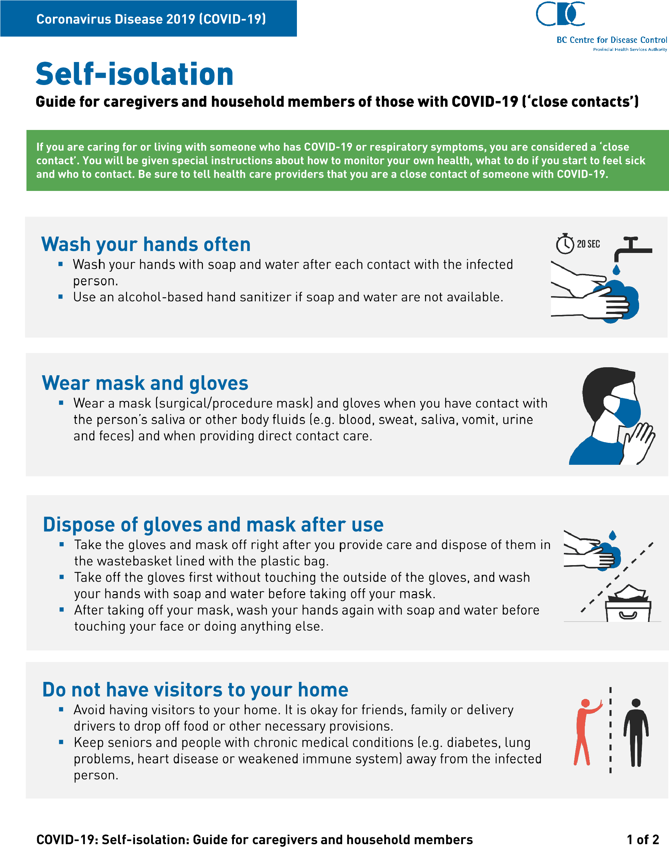

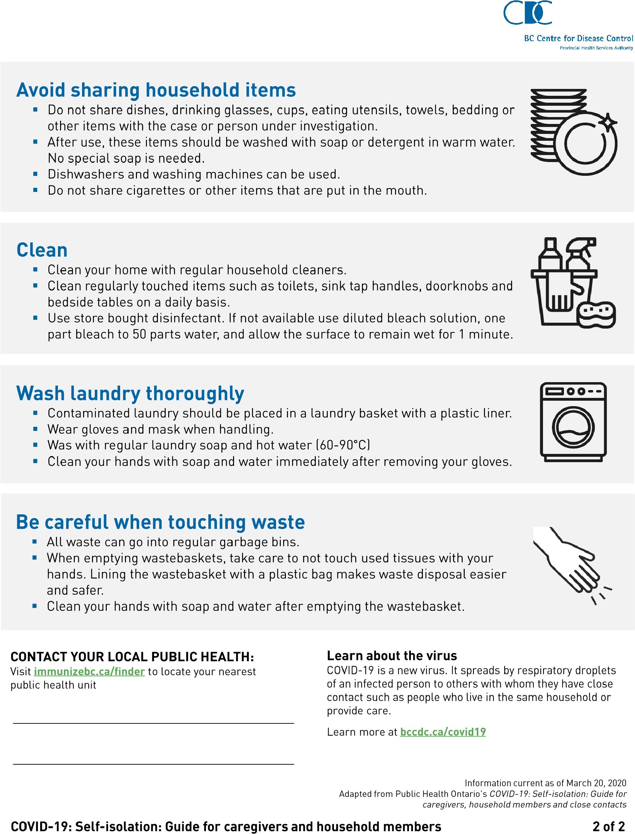

Appendix 2: Self-Monitoring
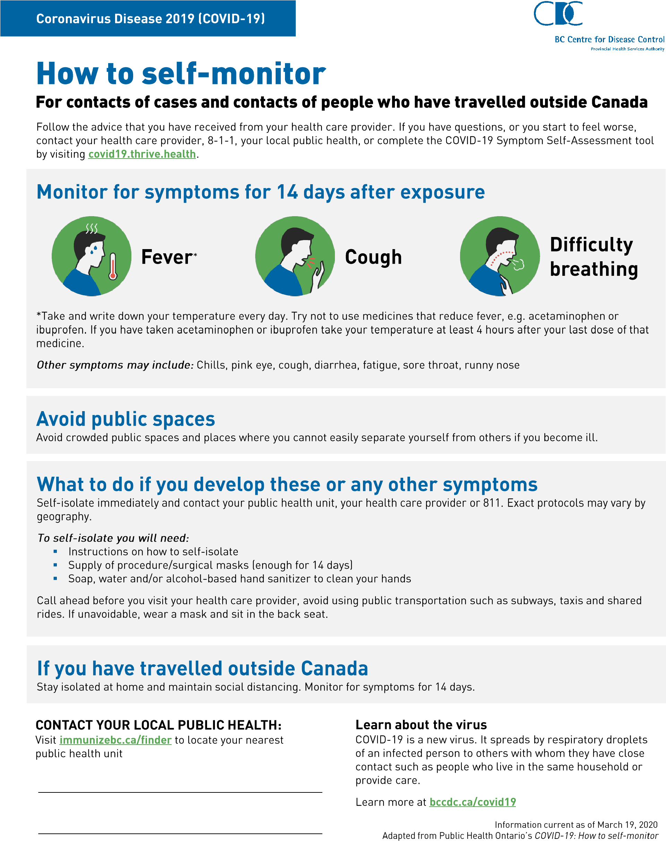

Appendix 3: Social Distancing

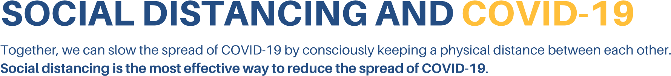
What does social distancing mean?
This means making changes in your behaviour to minimize close contact with others, including:
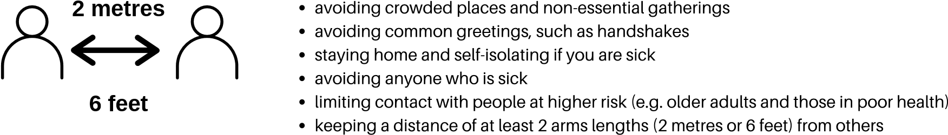
Here's how you can practise social distancing
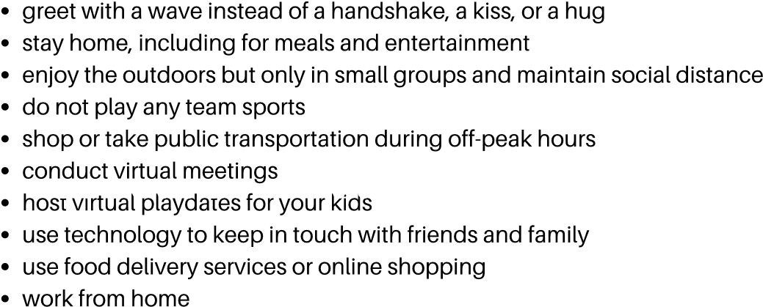
Remember to practise hand hygiene and respiratory etiquette
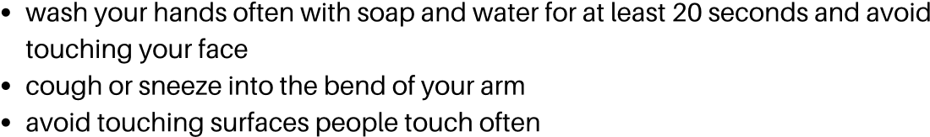
If you are concerned you may have COVID-19
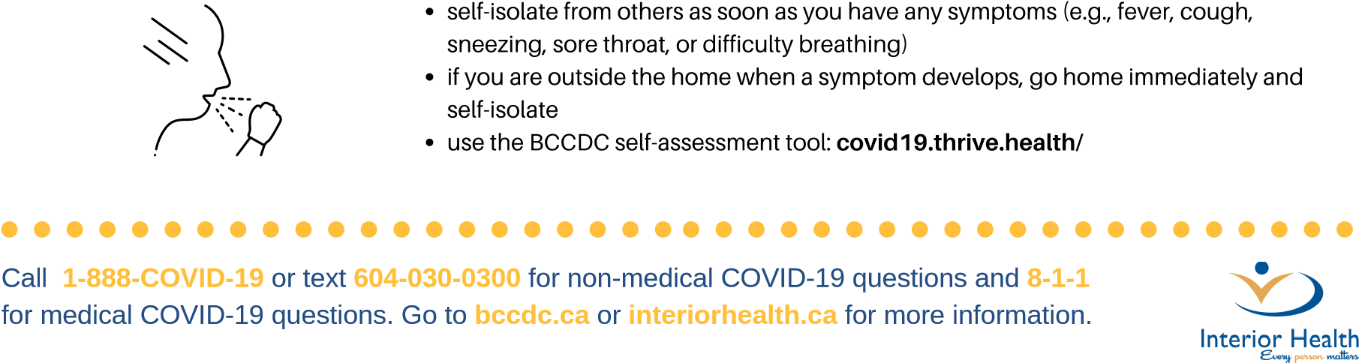
IH-PH-COV-177 20Mar2020
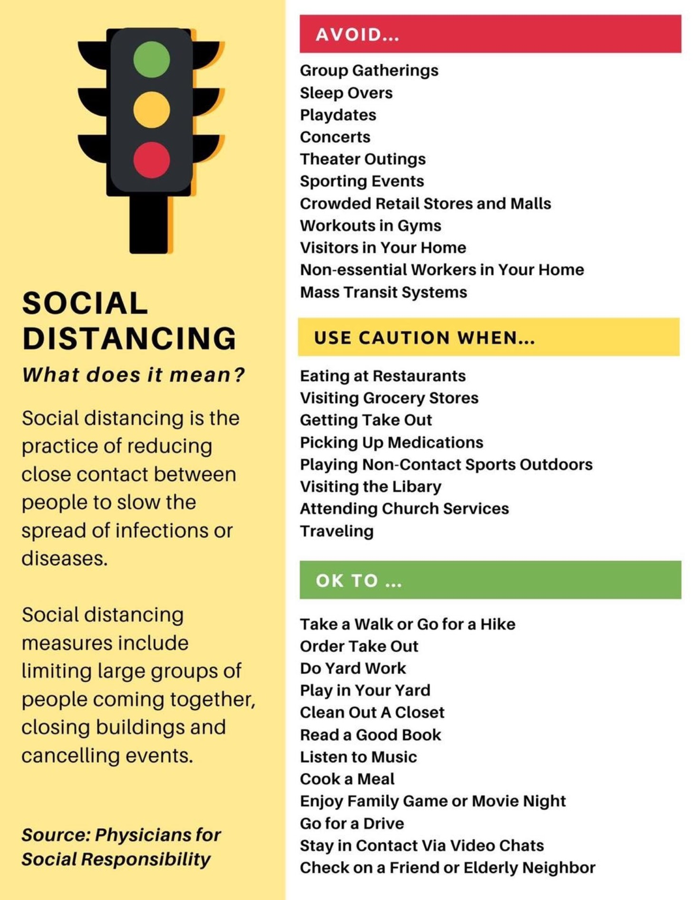

Physical distancing
Protect yourself, your loved ones and your community from COVID-19
March 23, 2020
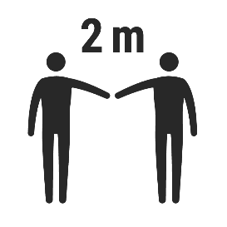
Physical distancing means making changes in your everyday routines in order to minimize close contact with others.
Keeping about two metres apart when we are outside our homes is something we can all do to help stop the spread of COVID-19.
Here are some other tips to practice physical distancing while keeping up mental wellness:
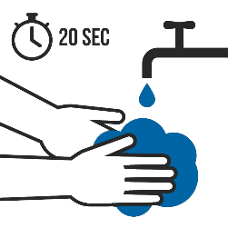

Greet with a wave instead of a handshake, kiss or
hug

Get groceries and medicines at
off
-
peak
times

Use food delivery services or online shopping

Go outside for some fresh air

Go for a run, bike ride, rollerblade, snowshoe, walk
the dog or get the mail while maintaining safe
physical distance from others

Use public transportation at off
-
peak times

Go for a walk with
family or others you are living
with

Work from home

Have kids play in the backyard or park

Exercise at home or outside
Remember to:

Stay at home when you’re sick, even if symptoms are mild

Avoid crowded places and non
-
essential gatherings

No
play dates,
group
walks, basketball
games or gathering
on the beach

Take care of your mental well
-
being through checking in with loved ones and self
-
care

Cough and sneeze into your elbow or sleeve

Wash your hands regularly
March 23, 2020
Learn more at bccdc.ca/covid19 Physical distancing: Protect yourself, your loved ones and your community from COVID-19

REDUCE THE SPREAD OF COVID-19
Coronavirus COVID-19
BC Centre for Disease Control | BC Ministry of Health
PHYSICAL DISTANCING IN PROGRESS
Maintain a distance of at least 2 arms lengths from others.
If you have fever, a new cough, or are
having difficulty breathing, call 8-1-1.

Appendix 4-9: Posters for OneSky Resources on Handwashing, Sneezing and Coughing Etiquette
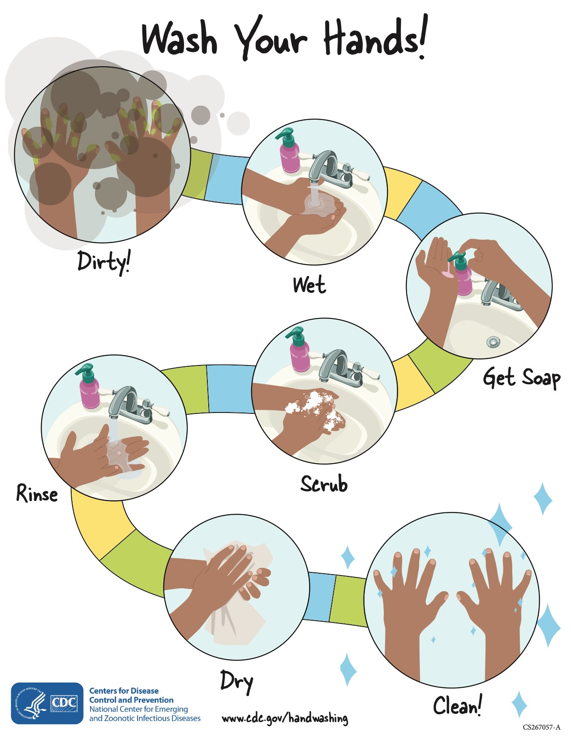

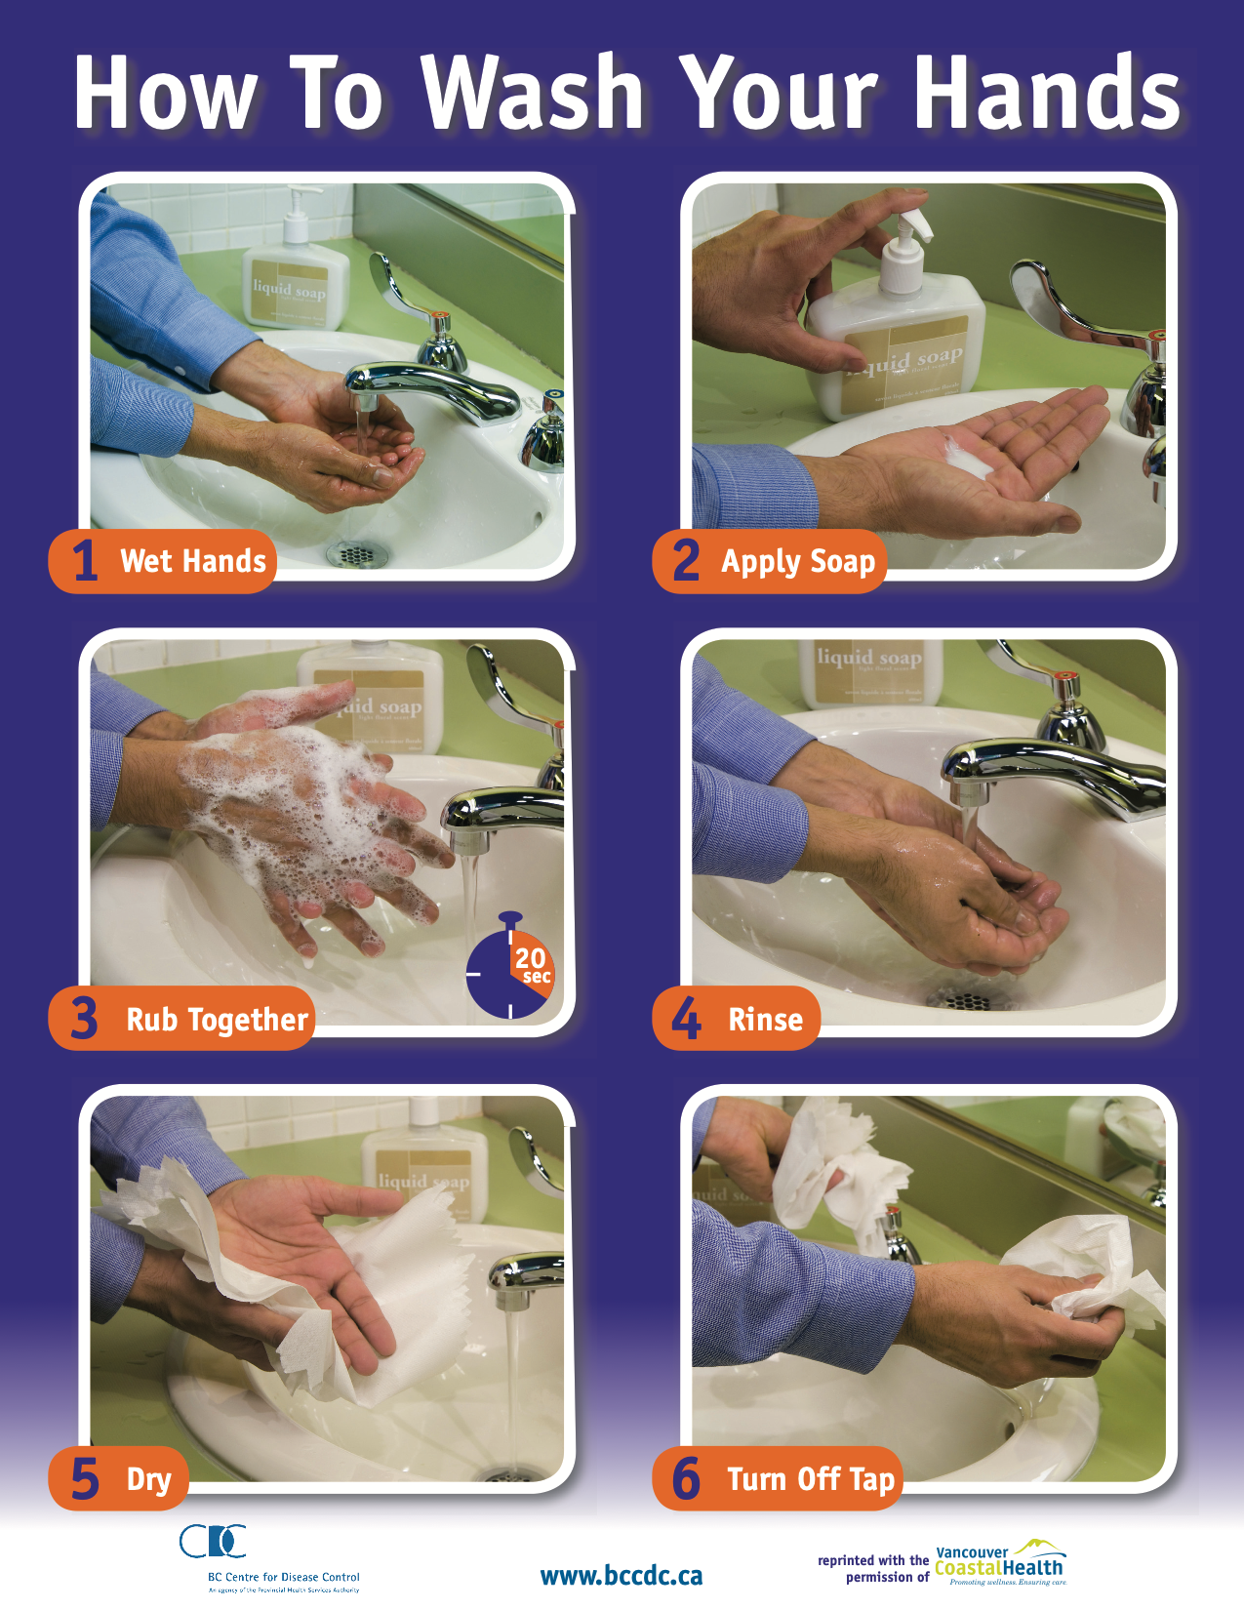

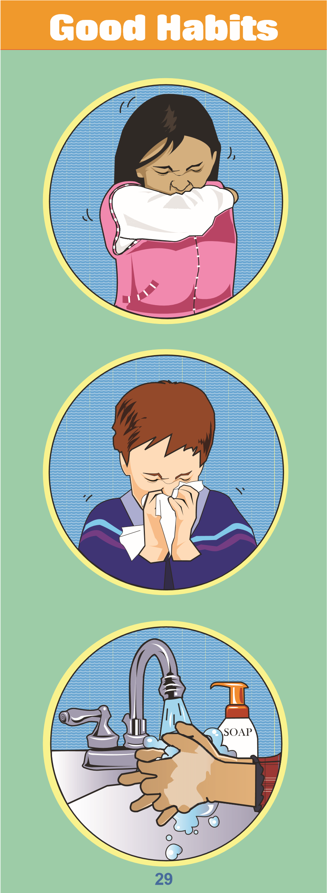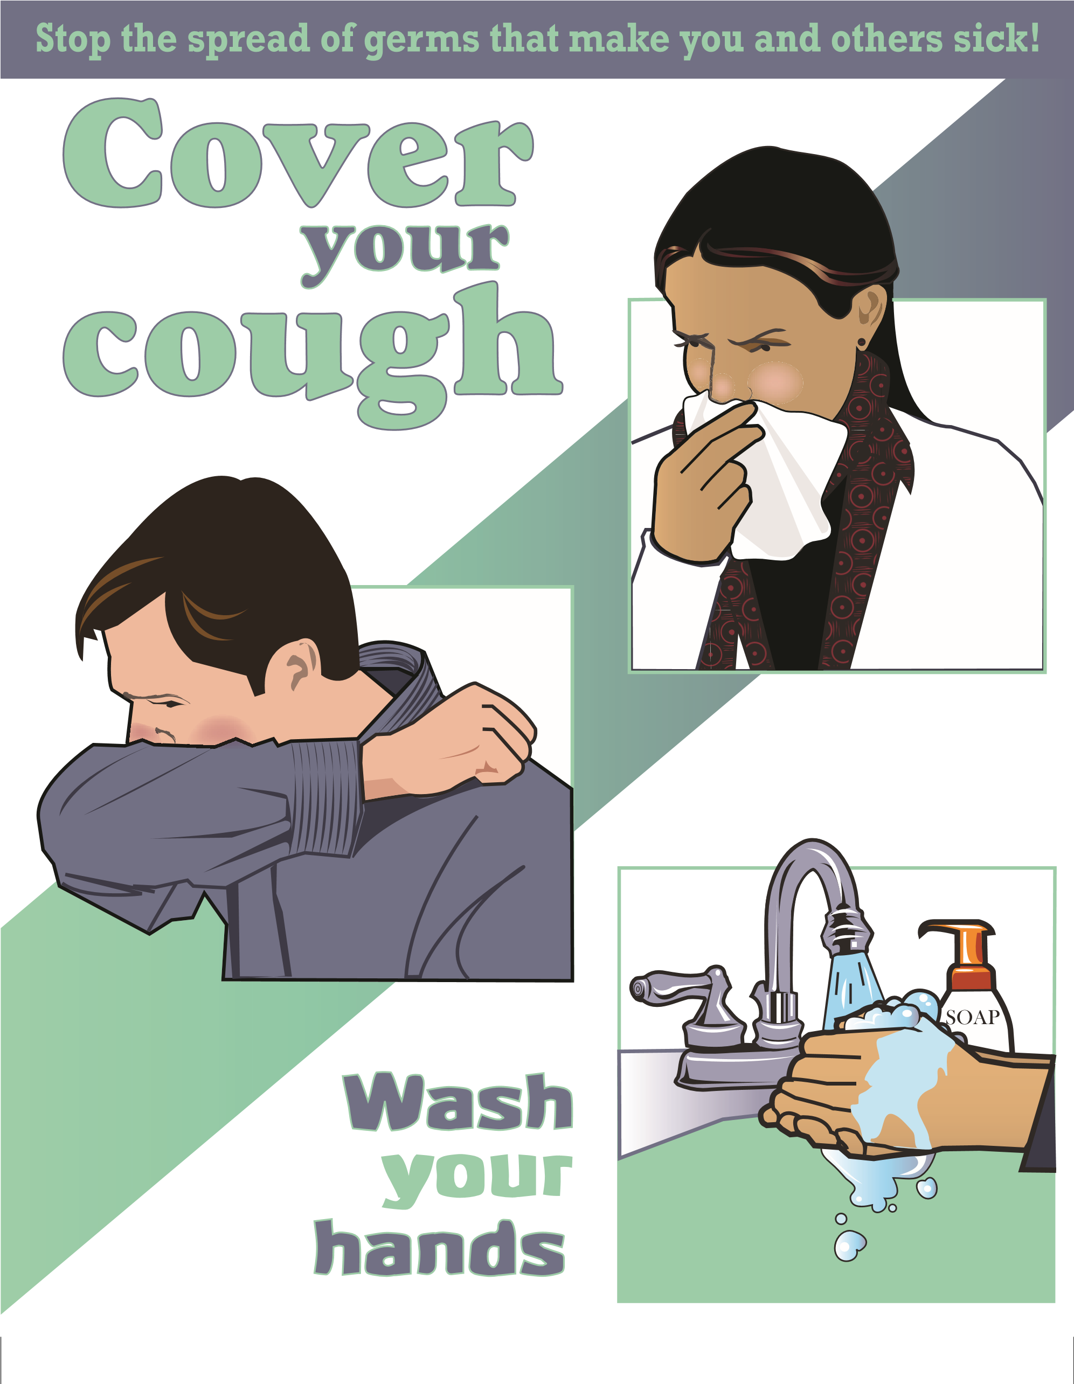
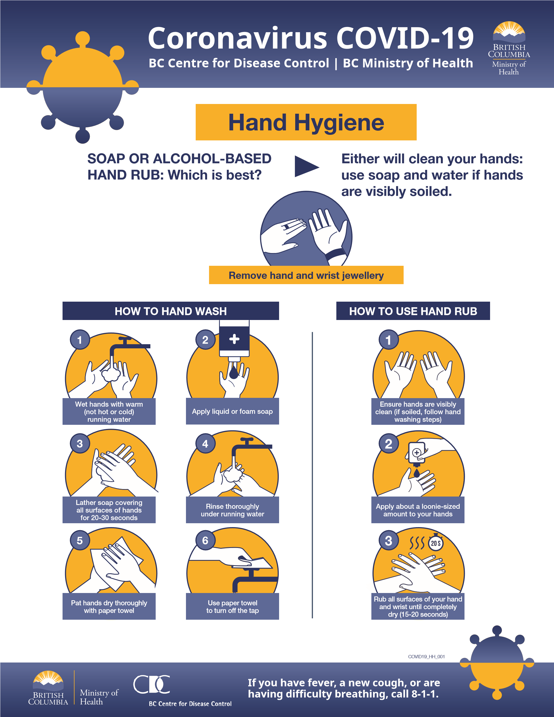

Appendix 10 – Posters re clients in ACCESS Facilities

Coronavirus COVID-19
BC Centre for Disease Control | BC Ministry of Health

FAMILIES AND VISITORS
STOP DO NOT ENTER
Essential visitors ONLY.
Essential visits include, but are not limited to:
1
2
3
Visits for compassionate care Visits considered paramount Existing registered volunteers (e.g., end of life and critical to patient/resident care and providing services as illness); and well being described above only.
(e.g. assistance with feeding or mobility, essential medical professionals, medication delivery); and
If in doubt, call to check if your visit is essential.
If you are sick, DO NOT ENTER.
Help us reduce the spread of COVID-19.
If you have fever, a new cou
g
h, or are
having difficulty breathing, call 8-1-1.
Appendix 11 - Universal “passive screening” poster
